Application Note:

Sweep injection points in the Guard Band of QAM 256 Narrow cast Channels: Can it be done?

Background: Forward Sweep in the CATV Network
Sweeping is very common in a CATV network these days and is the most effective way of maintaining the proper levels throughout the frequency range of the network. But the typical system is changing and many QAM channels are inserted at different parts of the network such as a hubsite. This is called narrowcasting. See Figure 1 and Figure 2

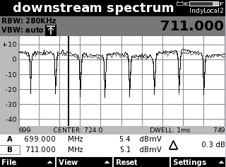
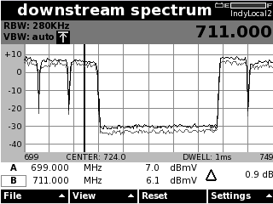

Figure 1 Open Band of Spectrum at Headend Figure 2 QAM Channels inserted at hubsite

This narrow casting of QAM channels can typical leave as much as 60 MHz of the Spectrum not being verified when then system is swept. See Figure 3.

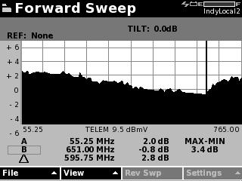
Not Swept

Figure 3

It is possible to insert sweep insertion carriers from the SDA 5500 transmitter at the headend and have very little effect to the quality of the QAM signal the customer is seeing. Inserting sweep pulses in the guard band 15dB below the carrier will work well. See figure 4

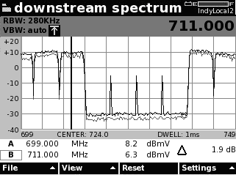

Figure 4 Sweep insertion carriers in the guard band.

Setting the Proper Headend Levels

If the QAM channels levels are set by using the SDA 5500 Sweep Transmitter then make sure the length of cable from the SDA 5500 and the forward Optical Transmitter is less than 25 feet.
Note: Longer than 25 feet can cause more loss at higher frequencies resulting in lower levels into the forward Optical Laser.
The QAM 256 channels are typically 5 to 7 db lower in level from the analog carrier and within +/- 1 dB across the frequency range. See figure 5

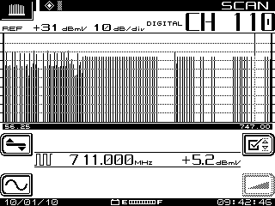

Figure 5 Scan mode of DSA 5500 transmitter.

Setting the Proper Sweep Insertion Point Level

Set the SDA 5500 transmitter in the transmitter diagnostic mode. Set the attenuator at 30 dB and the frequency to 3MHz higher than the frequency of the QAM carrier. (i.e. Narrowcast channel 717 MHz then the frequency of SDA 5500 at 720 MHz.) Then turn on the carrier.

Now at the test point on the optical transmitter use the DSAM in the spectrum mode and set the center frequency of the narrow cast channels to test.
Now decrease the attenuator setting on the SDA 5500 until the CW carrier appears to be about 15 dB below the QAM carrier in the guard band. See Figure 6 and 7.
Note: Remember the attenuator setting on the SDA 5500.

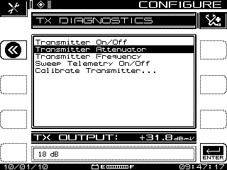
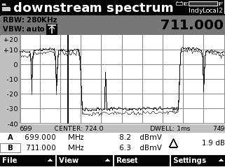

Figure 6 Transmitter CW insertion. Figure 7 CW carrier at guard band frequency

Setting the Sweep insertion level and frequencies on the SDA5500
Now configure the SDA 5500 sweep transmitter in the Sweep configuration screen. Set the sweep insertion level to (50 – the attenuation that was on the diagnostic screen.) See figure 8
Note: Set the telemetry level to 10 dB below the analog carrier.

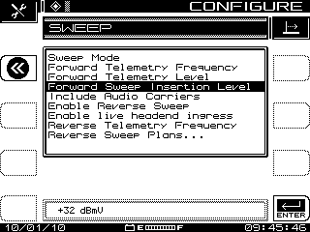

Figure 8 Sweep insertion level set.

Inserting Sweep insertion Points
In the channel plan configuration screen program the frequencies by adding of the sweep insertion points. Remember these carriers should be 3 MHZ above and below the center frequencies of the narrowcast QAM carriers. See figure 8

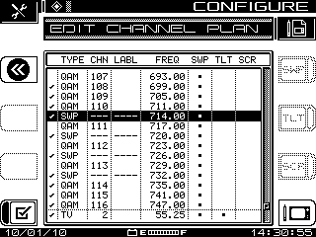

Figure 8
Now put the SDA 5500 in to the Sweep Mode.
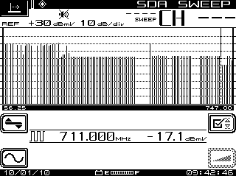
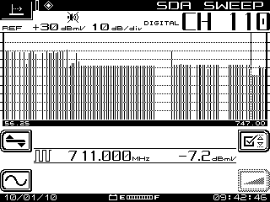

Figure 9 Sweep Mode QAM level Figure 10 Sweep insertion level

Verification
To verify the sweep insertion is not causing the QAM signal to degrade. Use a DSAM in the DQI mode. If the DQI reading 8 when the transmitter is off then it should read 8 when the transmitter in the sweep mode. If you are getting a poor DQI reading when the SDA transmitter is in the sweep mode then set the sweep insertion output level (figure 8) 2 dB lower and test again.

